Shutterstock Images
HOME PAGE – LARGE IMAGE
IF HOME PAGE IMAGES ARE GOING TO ROTATE THEN WE CAN ADD THE ADDITIONAL IMAGES BELOW.

MISSION IMAGE
Notes: section at the bottom with the graphs should be removed if possible. Open to suggestions if that section must stay.
Testimonial section: Fine with the image on there.

ABOUT US PAGE
MAIN PHOTO

EXPERTISE PHOTO
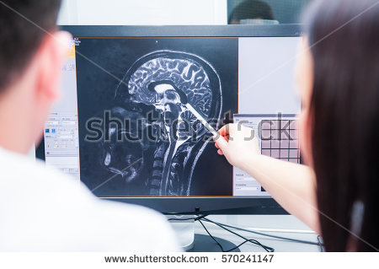
COVERAGE PHOTO

SERVICES PAGE

SELECT AN OPTION

AUTO INSURERS
LIFE & HEALTH

GOVERNMENT
MEDICAL LEGAL

AUTO INSURERS (SERVICE SECTION)
COMMENTS: NOT ENOUGH CONTENT. DON’T LIKE THE WAY THE SPECIALTY SERVICES ARE DISPLAYED. THEY HIGHLIGHT IN RED HOWEVER THERE IS NO CLICKING OPTION.
SUGGESTION: CAN WE CHANGE THE ARROW OPTION ON THE SERVICES? PERHAPS IT SHOULD CONTAIN DESCRIPTION TO EACH SERVICE OR DISPLAYED DIFFERENTLY.

LIFE AND HEALTH (SERVICE SECTION)
GOVERNMENT (SERVICE SECTION)
MEDICAL LEGAL

Note: Feel free to incorporate other images into the website as you see fit.

